**摘要征集 | 2025国际风景园林研讨会**

**Call for Abstracts |** **2025 International Landscape Architecture Symposium (ILAS)**

**韧性未来：持续性·包容性·科学循证**

**——2025国际风景园林研讨会**

2025 International Landscape Architecture Symposium (ILAS) - Sustainability · Inclusivity · Evidence-Based Science: Towards Resilient Futures

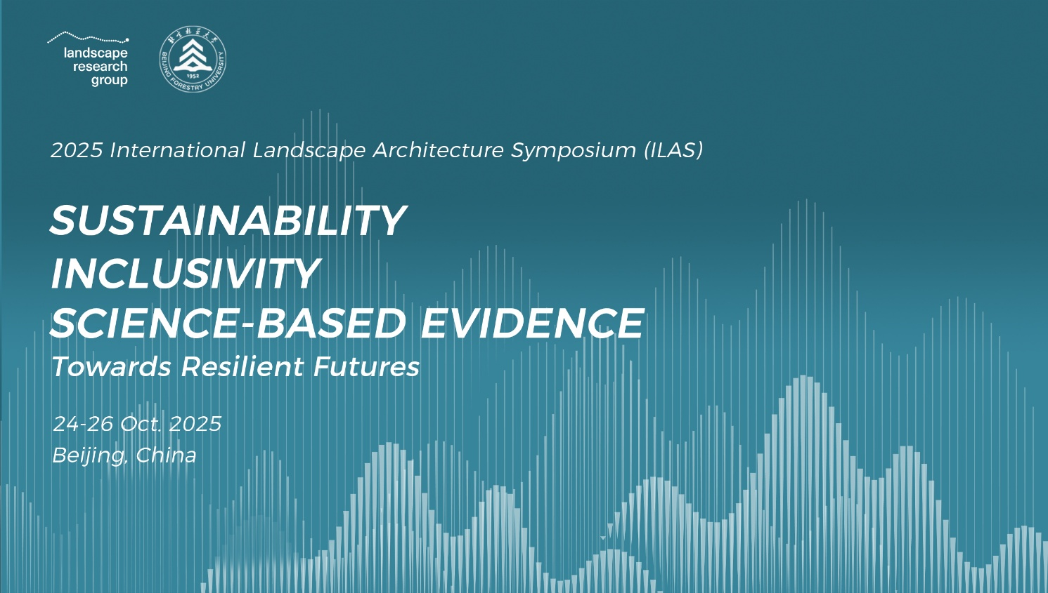

**会议简介 | Introduction**

北京林业大学与景观研究学会（Landscape Research Group，LRG）共同宣布将于2025年10月24日至26日在北京林业大学举办“韧性未来：持续性·包容性·科学循证——2025国际风景园林研讨会”。

Beijing Forestry University (BFU) and the Landscape Research Group (LRG) announce the “2025 International Landscape Architecture Symposium (ILAS) - Sustainability · Inclusivity · Evidence-Based Science: Towards Resilient Futures” that will take place at BFU campus in Beijing, China from 24 to 26 October 2025.

此次大会以21世纪全球发展的核心命题“可持续发展（Sustainability）”为主题，聚焦三大核心目标——持续性(Sustainability)、包容性(Inclusivity)和科学循证(Science-based Evidence)，与来自国内外的专家学者共同探讨探讨风景园林如何突破传统思维，通过跨学科对话和创新工程技术，实现生态韧性与社会公平的协同，推动资源的循环利用与环境保护，提升公共空间的可达性和包容性，并以科学循证为基础优化设计决策，为实现更加绿色、宜居和公平的未来，贡献风景园林的智慧和力量。

The conference will focus on the core global development issue of the 21st century, "Sustainability," with three main objectives: Sustainability, Inclusivity, and Evidence-based Science. Experts and scholars from both domestic and international backgrounds will discuss how landscape architecture can break through traditional thinking through interdisciplinary dialogue and innovative engineering techniques, achieving the synergy of ecological resilience and social equity, promoting resource recycling and environmental protection, improving the accessibility and inclusivity of public spaces, and optimizing design decisions based on evidence-based science. This aims to contribute the wisdom and power of landscape architecture to a greener, more livable, and fairer future.

**摘要征集 |** **Call for Abstracts**

大会现面向全球研究者、学者及相关从业者公开征集会议论文摘要，优秀成果将有机会通过口头报告形式分享研究成果。

摘要入选论文推荐全文提交至与会期刊特刊发表（需通过同行评审）。

The conference is now open for abstracts from researchers, scholars and related practitioners around the world. Outstanding submissions will have the opportunity to share their research findings through oral presentations..

Abstracts that are selected will be recommended for full submission for publication in a special issue of the participating journal (subject to peer review).

**1.分议题（Proposed Sub-Themes for the Symposium）**

（1）生态可持续性与环境韧性

本议题旨在探讨风景园林如何通过提升生态系统的功能和服务增强环境韧性，特别是在应对气候变化、极端天气等挑战中的作用。重点关注绿色基础设施、生态修复、生态网络连接以及生物多样性保护等策略，以提高城市环境的适应能力和恢复力，实现生态与社会双重可持续发展。

（2）社会包容性与景观普惠

本议题讨论风景园林如何通过设计和规划推动社会包容性，确保不同群体在城市空间中享有平等的资源与机会。聚焦于消除社会差异，提升公共景观的可及性与公平性，促进弱势群体、老年人及儿童等群体的社会融入，推动公共空间的普惠性设计。

（3）景观设计的循证创新路径

本议题探讨如何将科学循证方法引入景观设计实践，通过数据分析和实证研究优化设计过程和决策。重点讨论如何利用遥感技术、社会反馈和性能评估，提升设计的科学性与精准性，推动景观设计向更加有效、可持续的方向发展。

**The keynote speeches at this conference will focus on 3 main topics:**

1. Ecological Sustainability and Environmental Resilience

This topic aims to explore how landscape architecture can enhance environmental resilience by improving ecosystem functions and services, especially in responding to challenges such as climate change and extreme weather events. Focus will be placed on strategies like green infrastructure, ecological restoration, ecological network connectivity, and biodiversity conservation to improve urban environmental adaptability and resilience, achieving both ecological and social sustainability.

1. Social Inclusivity and Landscape Universality

This topic discusses how landscape architecture can promote social inclusivity through design and planning, ensuring that different groups have equal access to resources and opportunities in urban spaces. The focus is on eliminating social disparities, enhancing the accessibility and equity of public landscapes, supporting the social inclusion of vulnerable groups such as the elderly and children, and advancing inclusive design for public spaces.

1. Evidence-based Innovation Pathways in Landscape Design

This topic explores how evidence-based approaches can be integrated into landscape design practices, using data analysis and empirical research to optimize the design process and decision-making. It will focus on how technologies like remote sensing, social feedback, and performance evaluation can be used to enhance the scientific and precise nature of design, steering landscape design towards more effective and sustainable directions.

**2.投稿要求 (Submission)**

欢迎感兴趣的投稿者使用会议提供的模板投稿。

投稿语言应为中文/英文，摘要应包含标题、作者信息、摘要和关键词（具体形式见附件）；摘要字数应控制在400-800字内。

Interested authors are encouraged to submit abstract using the provided template.

The submission language should be either Chinese or English, and the abstract should include the title, author information, summary, and keywords (see appendix for the specific format). The word count for the abstract should be controlled within 400 - 800 words.

论文摘要提交邮箱：[papersbjfu@163.com](mailto:papersbjfu@163.com)

Email for submitting abstracts: [papersbjfu@163.com](mailto:papersbjfu@163.com)

**提交截止日期延后至：2025年8月15日**

**Submission deadline: 15 Aug, 2025**

**3.评审方式（Abstract Acceptance）**

论文摘要将由专家组成的评审委员会进行评估，标准如下：

* 摘要与会议主题的相关性；
* 所提出方法/工作的原创性和创新性；
* 摘要中呈现的解决方案或方法，及其应用于更广泛的研究的潜力；
* 摘要的质量和团队与摘要中所呈现的工作的相关性（摘要应该展示您的原创作品/研究）。

Abstracts will be evaluated by invited experts. The evaluation criteria are as follows:

* Relevance of the abstract to the conference theme;
* Originality and innovation of the proposed methods/work;
* The solutions or methods presented in the abstract and their potential application to broader research;
* Quality of the abstract and the relevance of the team to the work presented (the abstract should present your original work/research).

**日程安排 | Conference Agenda**

|  |  |  |
| --- | --- | --- |
| 日期 Date | 时间 Time | 日程 Agenda |
| 2025/10/24  24th October | 全天 | 会议报到 Conference Registration |
| 19:00-21:30 | 研究生论坛 Postgraduate Forum |
| 2025/10/25  25th October | 09:00-09:15 | 领导及嘉宾致辞  Addresses by Leadership & Distinguished Guests |
| 09:15-10:45 | 学术汇报（三位专家）  Academic Presentations (Three Experts) |
| 10:45-11:00 | 茶歇 Tea Break |
| 11:00-12:30 | 学术汇报（三位专家）  Academic Presentations (Three Experts) |
| 12:30-14:00 | 午餐午休 Lunch and Rest |
| 14:00-15:30 | 学术汇报（三位专家）  Academic Presentations (Three Experts) |
| 15:30-15:45 | 茶歇Tea Break |
| 15:45-16:50 | 期刊建设圆桌论坛  Journal Development Roundtable Forum |
| 16:50-17:00 | 主论坛总结 Main Forum Summary |
| 2025/10/26  26th October | 9:00-12:00 | 分议题论坛（三个会场）  Topic Sub-forums（Three Parallel Session） |

**注册缴费 | Registration and Payment**

**1. 注册类型（Registration Types）：**

（1）标准注册

2025年9月15日（含）前完成会议注册并缴费可享受早鸟价：1000元/人

2025年9月15日（含）起至报到当天注册并缴费：1200元/人

（2）学生注册

2025年9月15日（含）前完成会议注册并缴费可享受早鸟价：600元/人

2025年9月15日（含）起至报到当天注册并缴费：800元/人

（3）现场注册

现场设置刷卡机，支持现场缴费注册，注册费统一为1200元（学生800元）。

*本次论坛仅开放线下参会通道，采用实名制注册及现场报到的方式，请按照指定方式缴纳会议注册费后扫描下方二维码填报参会信息并上传支付凭证，组委会将在收到报名表后通过邮件向您发送参会通知及注意事项。

(1) Standard Registration

Early bird price: 1000 CNY/person for registration and payment completed by September 15, 2025 (inclusive).

Regular price: 1200 CNY/person for registration and payment completed after September 15, 2025 and on the day of registration.

(2) Student Registration

Early bird price: 600 CNY/person for registration and payment completed by September 15, 2025 (inclusive).

Regular price: 800 CNY/person for registration and payment completed after September 15, 2025 and on the day of registration.

(3) On-site Registration

On-site card machines will be available for payment and registration. The registration fee will be 1200 CNY (800 CNY for students).

*The forum is only open for on-site attendance, and a real-name registration system will be used. After completing payment, please scan the QR code below to fill in your registration information and upload the payment proof. The organizing committee will send you a participation notice and guidelines via email after receiving your registration form.



**2.缴费方式（Payment Methods）：**

（1）对公转账

户名：北京《风景园林》杂志社有限公司

开户行：中国农业银行股份有限公司北京海淀东区支行

账号：11250501040031548

*汇款时请务必备注:“ILAS论坛+参会者姓名”，并将汇款回单或截图上传至注册表单内的指定位置。

发票：本次论坛每笔注册费与发票一一对应，默认使用电子发票，开票类目为“会议费”，请务必在填写报名信息时将开票信息填写完整，电子发票将在论坛结束后统一开具并发到您填写的邮箱中。发票仅可开具一次，选择“无需发票”则默认发票抬头为“个人”，不接受更换抬头或补开，请务必在首次报名时核对确认相关信息。

（2）现场缴费

论坛鼓励提前注册缴费，现场仅提供POS机刷卡和实时转账汇款方式，不支持现金及扫码支付。

（3）退款规定

因论坛需提前准备相关材料，已报名缴费的人员仅可在2025年9月30日前联系组委会提交退款说明及申请，2025年10月1日0点起无特殊原因不接受退款申请。

(1) Bank Transfer

Payee: Beijing "Landscape Architecture" Magazine Co., Ltd.

Bank: Agricultural Bank of China, Haidian East District Branch, Beijing

Account Number: 11250501040031548

*When making a transfer, please ensure to note: "ILAS Forum + Attendee's Name," and upload the payment receipt or screenshot to the designated location in the registration form.

Invoice:

Each registration fee corresponds to one invoice. The default invoice type is electronic, under the category of "Conference Fee." Please fill out the billing information carefully when completing the registration form. The electronic invoice will be issued after the forum ends and sent to the email provided. The invoice can only be issued once. If "No Invoice" is selected, the default invoice title will be "Individual," and we do not accept title changes or reissuance. Please verify the information when first registering.

(2) On-site Payment

The forum encourages early registration and payment. On-site, only card payment via POS machine or real-time bank transfer will be available. Cash and QR code payments are not accepted.

(3) Refund Policy

Due to the need for preparing materials in advance, registered and paid attendees may submit a refund request to the organizing committee by September 30, 2025. Refund requests will not be accepted after 00:00 on October 1, 2025, unless under special circumstances.

**主办单位 | Organizers**



北京林业大学

Beijing Forestry University (BFU)



景观研究学会

Landscape Research Group (LRG)

**承办单位 | Host**



北京林业大学园林学院

School of Landscape Architecture, BFU

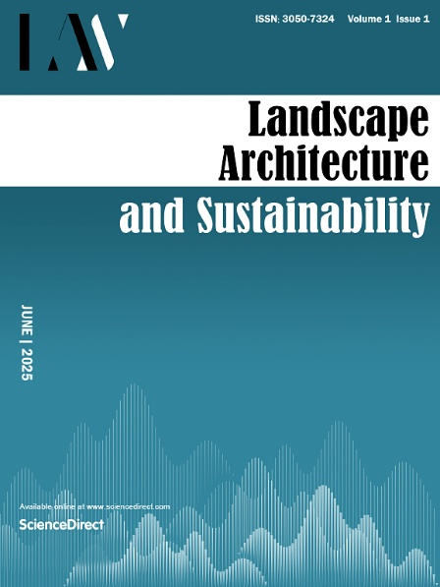

《风景园林与可持续发展》杂志 *Landscape Architecture and Sustainability*

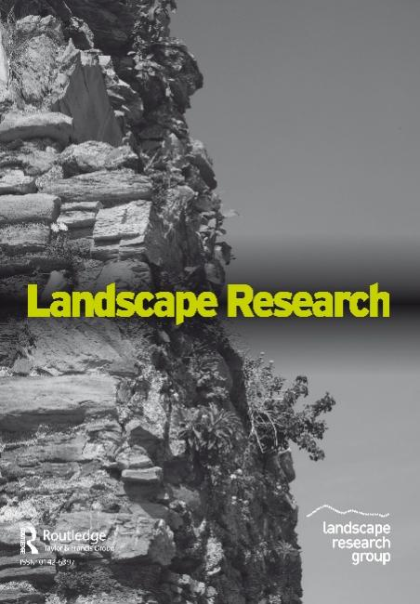

《景观研究》杂志

*Landscape Research*



《风景园林》杂志

*Landscape Architecture*

**附件|Appendix**

@AbstractTemplate-en.docx

@ 摘要格式模板-中文.docx

附：

LRG简介：

景观研究学会（Landscape Research Group，简称LRG）是一个独立运作的非营利性国际组织，致力于在全球学术共同体中，通过知识传播、交流与协作推动跨学科及超学科的景观研究与发展。LRG于1967年在英国创立，通过旗下期刊《景观研究》、系列学术活动以及合作项目，联结全球的研究者与实践者。我们深入探索景观的多元维度（从自然环境到城市设计），并聚焦能驱动积极变革的知识交流、学术对话与创新研究。LRG的运营团队、理事会成员、国际会员及合作伙伴拥有广泛的学科背景，涵盖地理学、城乡规划学、风景园林学、城市设计、考古学、生态学等众多领域，而这种多元性已成为系统认知景观演变脉络与未来趋势的重要基石。

LRG is an international, independent and not-for-profit organisation working to advance interdisciplinary and transdisciplinary landscape research through dissemination, communication and exchange across global communities of interest.

Founded in England in 1967, LRG connects researchers and practitioners worldwide through our journal Landscape Research, events, and collaborative projects. We explore all aspects of landscape—from natural environment to urban design—with a focus on knowledge exchange, dialogue and research that fuels positive change.

Our staff, Board of Trustees, members and partners represent a broad range of disciplines: geographers, planners, landscape architects and urban designers, archaeologists and ecologists, to list but a few. This diversity is fundamental to a holistic understanding of landscape – its evolution and its future.

期刊《景观研究》（*Landscape Research*）简介

学术期刊《景观研究》（Landscape Research）实行全流程同行评审，入选JCR期刊引证报告，常设研究论文、批判性评论、影像实证及深度书评四大核心栏目。该期刊由国际权威出版集团泰勒-弗朗西斯（Taylor & Francis）发行，创刊五十余载，奠定了深厚的学术根基（常年位居全球科技期刊影响力前5名）。近年来，其读者覆盖面持续扩展，影响因子与引用频次逐年跃升。主编汉内斯·帕朗教授（Prof. Hannes Palang）领衔的国际化编委团队（成员已遍及亚、欧、美三大洲），旨在融汇多元学科视角，以全球视野引领景观研究与发展。

*Landscape Research*, our academic journal, is a fully peer-reviewed and Impact-Factor listed journal containing articles, critical review essays, photo essays and book review forums.Published by Taylor & Francis, the journal is well-respected and solidly established with a consistently growing readership, impact factor and citation rates. Our experienced Editorial team, led by Professor Hannes Palang, has a global coverage and outlook with representatives across three continents and a range of expertise.

**官方网址或图片二维码查看**

https://landscaperesearch.org

